CATHOLICATE COLLEGE PATHANAMTHITTA

## Project Report On

#### COVID- 19 V/s Fear Factor: A Quantitative Analysis

***Submitted in partial fulfillment***

***of the requirement for the award of the degree of***

#### BACHELOR OF SCIENCE IN PHYSICS

***Under***

**MAHATMA GANDHI UNIVERSITY, KOTTAYAM, KERALA**

***By***

**B ARYA JAGISH Reg No: 190021040015**

***Under the guidance of***

**Dr. ANOOP P D**

**ASSISTANT PROFESSOR, DEPARTMENT OF PHYSICS CATHOLICATE COLLEGE, PATHANAMTHITTA**

# CERTIFICATE

*This is to certify that the dissertation entitled* **“COVID-19 V/s Fear Factor: A Quantitative Analysis”** *is a bonafide record of original work carried out by* ***B ARYA JAGISH*** *in partial fulfillment of the requirement for the award of degree of* ***Bachelor of Science in Physics*** *under* ***Mahatma Gandhi University****, Kottayam during the year 2019 – 2022.*

**Dr. Soosen Samuel M**

*Head of the Department Postgraduate and Research Department of Physics Catholicate College, Pathanamthitta*

# CERTIFICATE

*This is to certify that the dissertation entitled “***COVID-19 V/s Fear Factor: A Quantitative Analysis***” is a record of original work carried out by* ***B ARYA JAGISH*** *under my supervision and guidance during 2019 – 2022 in the partial fulfillment of the requirement for the award of degree of* ***Bachelor of Science in Physics*** *under Mahatma Gandhi University, Kottayam.*

***Dr. Anoop P D***

*Assistant Professor, Postgraduate and Research Department of Physics, Catholicate College, Pathanamthitta.*

External examiners: 1.

2.

# DECLARATION

I hereby declare that the project report entitled **“COVID-19 V/s Fear Factor: A Quantitative Analysis”** submitted to the Department of Physics, Catholicate College, Pathanamthitta is a record of research work done by me under the supervision and guidance of Dr. Anoop P D, Assistant Professor, Department of Physics, Catholicate College, Pathanamthitta in partial fulfillment for the award of Degree of Bachelor of Science in Physics under Mahatma Gandhi University, Kottayam.

The information and data given in the report is authentic to the best of my knowledge.

**B ARYA JAGISH**

# ACKNOWLEDGEMENT

First of all I would like to thank the supreme power, the Almighty God, obviously the one who has always guided me to work on the right path of life.

Without His grace, this project could not become a reality.

I am highly obliged in taking the opportunity to sincerely thank our project guide **Asst. Prof. Dr. Anoop P D** [Dept of Physics, Catholicate College, Pathanamthitta] who helped me immensely throughout the course of the project. I undeservedly express my gratitude and indebtedness for his guidance in making this project a successful venture.

I am also thankful to all the faculty members and non-teaching staffs of the Department of Physics, Catholicate College , Parthanamthitta who have extended their kind cooperation.

I would like to express my gratitude to my parents for their moral support which had been a pivotal factor to the successful completion of the project. Finally, I extend my heartiest thanks to my friends and well-wishers for being with us and extending encouragement throughout the project.

**B ARYA JAGISH**

**CONTENTS**

##### CHAPTER 1:

Introduction Problem statement

##### CHAPTER 2:

Theory Analysis

##### CHAPTER 3:

Mathematical Model Model Formulation

##### CHAPTER 4:

Fear Factor

##### Expression For Fear Factor

CHAPTER 5:

##### Conclusion

Future enhancement

##### CHAPTER 6:

Reference

CHAPTER-1

**INTRODUCTION**:

Corona virus disease 2019 (COVID 19) is an infectious disease caused by severe acute respiratory syndrome corona virus 2 (SARS-CoV-2). It was first identified in December 2019 in Wuhan, China, and has resulted in an ongoing pandemic. The first case may be tracked back to 17 November 2019. As of 8 June 2020, more than 6.98 million cases have been reported across 188 countries and territories, resulting in more than 401,000 deaths. More than

3.13 million people have recovered.

COVID-19 is spread by dust particles and fomites while close unsafe touch between the infector and the infected individual. Airborne distribution has not been recorded for COVID-19 and is not known to be a significant transmission engine based on the empirical evidence; although it can be imagined if such aerosol-generating practices are carried out in medical facilities. It is most contagious during the first three days after the onset of symptoms, although spread is possible before symptomsappear and from people who do not show symptoms. Corona viruses are a large family of viruses that are known to cause illness ranging from the common cold to more severe diseases such as Middle East Respiratory Syndrome (MERS) and Severe Acute Respiratory Syndrome (SARS).

Currently, COVID-19 is of great concern to researches, governments, and all people because of the high rate infection spread and the

significant number of deaths occurred. Mathematical models are useful to understand the behavior of an infection when it enters a community and investigate under which conditions it will be wiped out or continued. Mathematical modeling can provide useful insights for mitigating emerging infectious diseases such as SARS-CoV, MERS-CoV, COVID-19 outbreaks. Particularly, the mathematical modeling becomes more important as the movement of people and other living organisms increases due to globalization.

#### PROBLEM STATEMENT:

In this project, we dived deep into the details of THE COVID PANDEMIC AND INTRODUCED A NEW FACTOR CALLED **FEAR FACTOR.** With the

available data we came up with some observations and conclusions.

This analysis mainly focuses on

* The current COVID-19 situations in India.
* Interpretation of Mathematical Model Graphically.
* Introduction of a new factor called Fear Factor.

CHAPTER-2

#### THEORY:

In late December 2019 a new (novel) corona virus was identified in China causing severe respiratory disease including Pneumonia. It was originally Named Novel Corona virus and The World Health Organization (WHO) advised the following language associated with the virus. The virus causing the infection has been named – severe acute respiratory syndrome corona virus 2 (SARS-CoV-2).

The disease caused as a result of infection is named – corona virus disease (COVID-19). COVID-19 has been categorized as an airborne High Consequence Infections Disease. SARS-CoV-2 is spreading globally and can be seen on the WHO situation reports dashboard which is updated daily. There are now vaccinations available. As it is a viral infection, antibiotics are not an effective treatment.

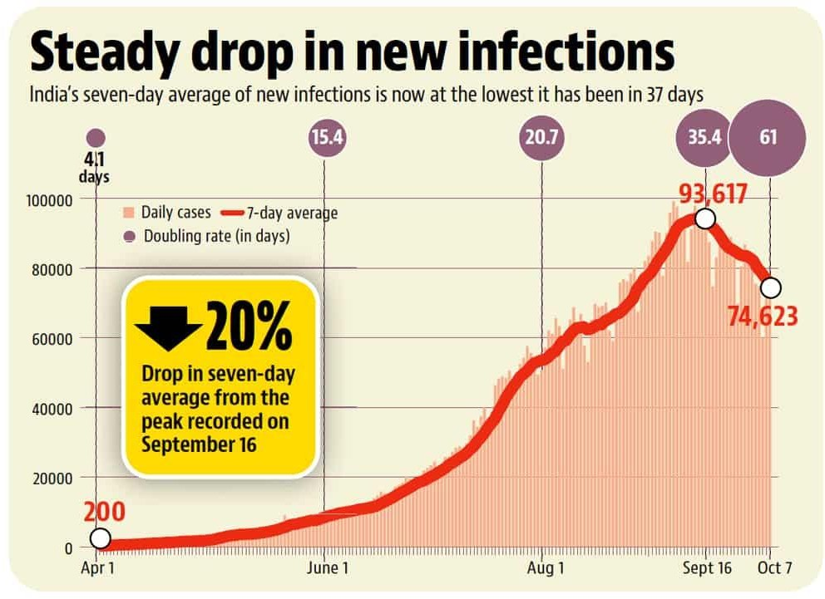

A global coordinated effort is needed to stop the further spread of the virus. A pandemic is defined as ‘occurring over a wide geographic area and affecting an exceptionally high proportion of the population’. On 30th January 2020 India recorded its first COVID-19 case in state of Kerala. It was a student who had travel history to China. And till the start of June India has over 200 thousand confirmed cases.

###### CONFIRMED CASES OF COVID-19

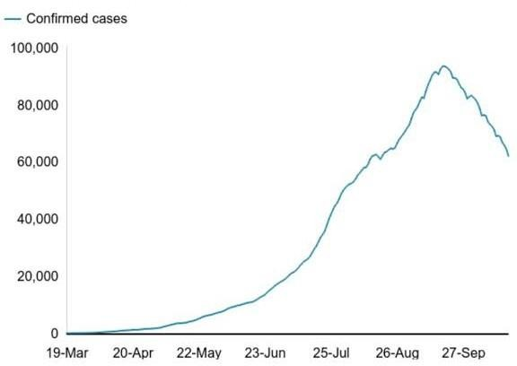

Government of India is taking all necessary steps to ensure that we are prepared well to face the challenge and threat posed by the growing pandemic of COVID-19, the Corona virus. The most important factor in preventing the spread of virus locally is to empower the citizens with the right information and taking precautions as per the advisories being issued by Ministry of Health & Family Welfare.

#### ANALYSIS:

As of 19 April 2022, India reported a total of 43,045,527 confirmed cases; and a total of 521,966 deaths have been reported.

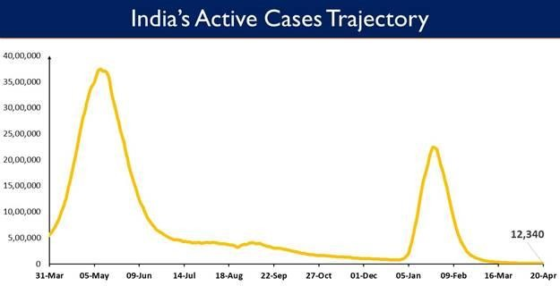

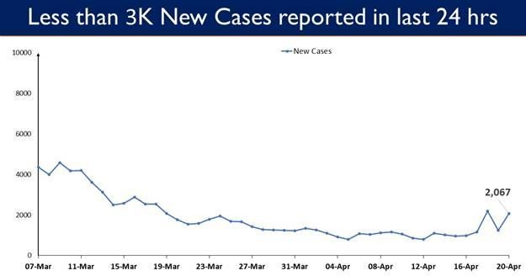

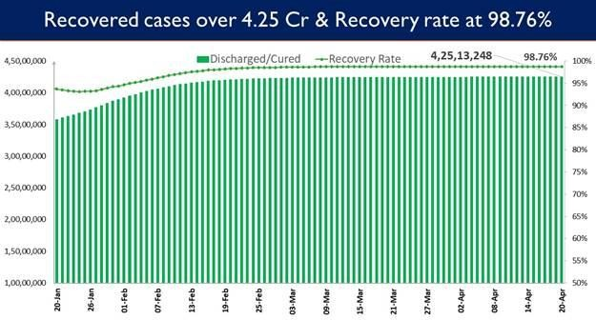

###### Why are new COVID-19 variants emerging time and again?

Over the course of years, we have come to accept the emergence of new variants and have understood the science behind it. Like all other viruses, the SARs-COV-2 viruses are bound to emerge. “When a virus replicates or makes copies of itself, it sometimes changes a little bit, which is normal for a virus. These changes are called mutation” explains the World Health Organization.

Having said that new COVID variants have emerged time and again and while some variants have been easier to tackle and tame, the Delta and the latest variant Omicron have wreaked a lot of havoc around the world and in India.

###### The Delta Variant and India’s second corona virus wave

The devastations caused by the second wave of corona virus is certainly unforgettable. While lax in taking precautions and negligence were some of the reasons behind the surge in the number of COVID cases, the Delta variant was said to have driven the second wave. With the help of

genome sequencing and sample testing, the first case of double mutation in India was discovered in the state of Maharashtra. Following the second wave in India, the government announced another deadly variant, known as **Delta Plus Variant** and **Kappa Variant.** The Kappa variant of SARs-COV-2 virus was first detected in India in December 2020. It is known as double mutant strain of the virus, scientifically called B.1.167.1.

###### Omicron variant is currently the most dominant strain globally:

The Omicron variant, first detected in South Africa, has been declared a variant of concern by the World Health Organization. While the new corona virus variant is said to be mild so far, the high rate of infectiousness and transmissibility has raised concerns around the world. The global health agency has warned against dismissing the new variant as mild and emphasized that it could pose “very high” risk in the coming days, overwhelming the healthcare system.

Currently, the Omicron variant has impacted several countries including India. Although most cases of Omicron infection have been mild, reports of death have come to the forefront in the recent past.

###### New COVID variant that could pose possible threat

Given that viruses mutate, new variants will emerge from time to time. Just when we had begun understanding the Omicron variant, a new COVID-19 variant was detected in France. So far, at least 12 cases of the

new variant have been reported near Marseilles. The infections have been associated with travel to African country Cameroon.

###### Are the symptoms in new emerging variants different from the original strain?

As far as COVID-19 symptoms are concerned, irrespective of the emergencies of the new variants, it remains to be same in most cases. The new Omicron variant however is said to showcase unusual symptoms which have not been seen with the previous variants. ‘Scratchy throat’, extreme body pain, night sweats, nausea, vomiting and loss of appetite are some of the new symptoms associated with the Omicron.

CHAPTER-3

#### MATHEMATICAL MODEL:

##### MATHEMATICAL MODEL FOR CORONAVIRUS DISEASE 2019:

According to figures collated by John Hopkins University, the largest cases occurred at the US. Nothing that more than 77,000 deaths happened, it also has the world’s highest death toll.

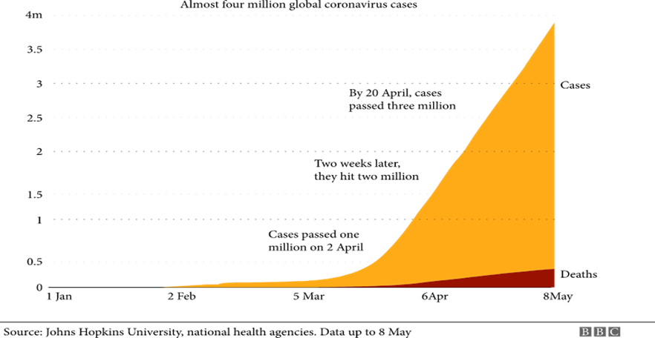

A modified SIR epidemic model is presented to project the actual number of infected cases and discussed statistically the parameters used in the proposed model and showed how to control this infection. Several researches developed different models of COVID-19 and studied dynamical behaviors. From the above discussion, it was concluded that human contact is the potential cause of outbreaks of COVID-19 spread. In order to do this, we first divided the total population into three compartments; infected, recovered and feared population. The study will lead to Mathematical model formulation in which

the interaction of the exposed population and infected population occurred to the susceptible populations.

#### MODEL FORMULATION:

In this section, we develop the mathematical model by taking into account the above assumptions.

**PARAMETERS AND DESCRIPTIONS:**

|  |  |
| --- | --- |
| Symbols | Description |
| I R F A X  µ  θ  € | Infected Population Recovered Population Feared Population Total Population  Total Population to Infected Population Rate  Natural death rate plus disease related death rate  Infected to recovered rate Birth Rate |

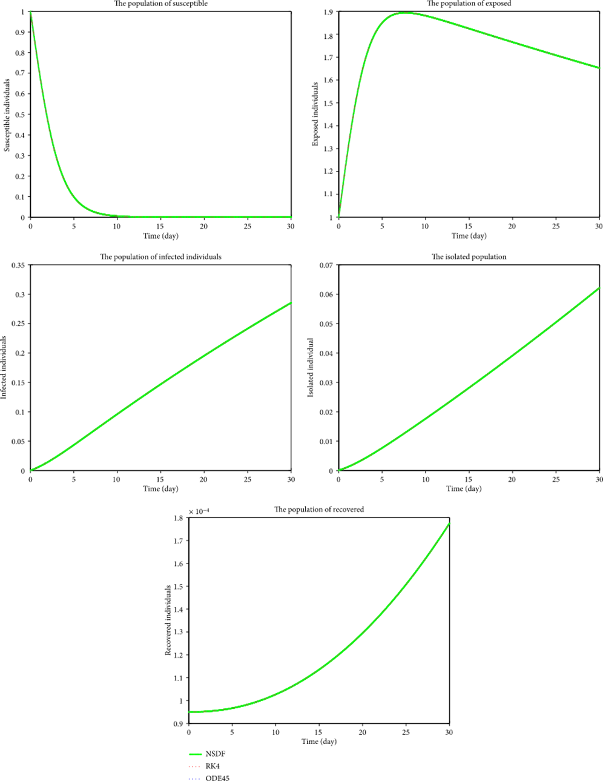

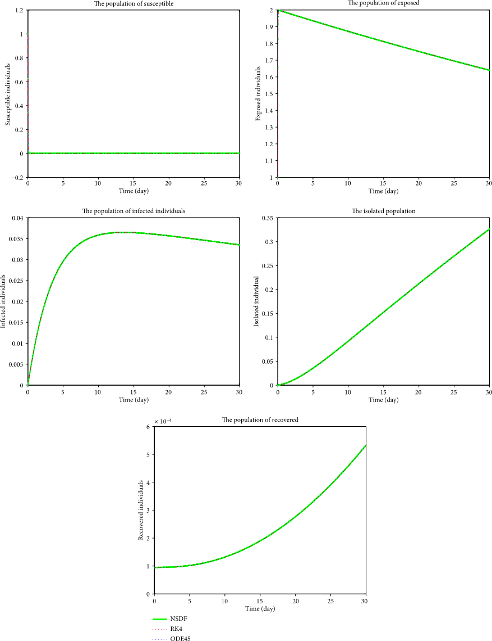

### CHAPTER-4

#### FEAR FACTOR:

Fear is the very thing that implies us to take our vaccines, to follow COVID protocol as best as we can, to lie low and locked down for what seems an indeterminable period. Certain aspects of the disease, such as the uncertainty about how it is spread, its evolution or about the immunity of patients who have been infected, or the absence of a vaccine to counter the disease, have led to an increased feeling of fear among the population.

Studies have identified various domains of fear related to the fear of COVID-19 infection, such as fear of oneself for their family members getting infected, fear of having economic losses and being unemployed, or fear of avoidance etc. The deaths caused due to the pandemic have been enormous, inflicting a sense of fear among people. Fear is defined as “a basic, intense emotion aroused by the detection of imminent threat, involving an immediate alarm reaction that mobilizes the organism by triggering a set of physiological changes.”

Due to the nature of the virus and how it spreads, many countries have instituted strict quarantine and isolation measures amid closure of organizations and schools. During the peaks of COVID -19, many schools and colleges have had to resort to online learning, with uncertainty about reopening or appropriate protocols to implement. Thus fear is an important factor affecting the spread of COVID -19.

#### EXPRESSION FOR FEAR FACTOR:

From the parameters and descriptions of the mathematical model mentioned above, we get

𝑑𝐼

𝑑𝑡

*= A - x F (t) + x I (t) - µ I (t) (1)*

𝑑𝑅

𝑑𝑡

*= -µ R (t) +* θ *F (t) (2)*

𝑑𝐹

𝑑𝑡

*= x I (t) –* θ *R (t) +x f (t)……… (3)*

𝑑𝑅

𝑑𝑡

𝑑

=

𝑑𝑡

*(I+R+F)*

*= A-x F(t)+x I(t)-µ I(t) -µ R(t)+* θ *F(t)+ x I(t)-* θ *R(t)+ x F(t)*

*=A + 2x I(t) - µ(I+R) -* θ *(R-F)*

*=A+2x I- µ(I+R )-* θ*(A-I-2F)*

*=A+2x I- µI- µR -* θ *A+I* θ*+ 2F* θ

*=A+2xI-µ (A-F) -* θ *A+I* θ *+2F* θ

𝑑𝐹+θ𝑅−𝑥𝐹

*=A (1-µ-* θ*) +F (µ+2* θ*) + (2x+* θ*)*𝑑𝑡 *……… (4)*

𝑥

𝑑𝐹

𝑑𝑡

*= x(I+F) -* θ *R*

𝑑𝐹

𝑑𝑡

*=x(A-R)-* θ *R*

𝑑𝐹

𝑑𝑡

*=xA-(x+* θ*)R*

*(x+* θ*)R =x A-*

𝑑𝐹

𝑑𝑡

𝑥𝐴− 𝑑𝐹

*R =* 𝑑𝑡

𝑥+θ

− 𝑑𝐹

*R =* 𝑑𝑡 +𝑥𝐴

𝑥+θ

*Substitute R in (4);*

−𝑑𝐹

𝑑𝐴= 𝐴 (1 − 𝜇 − [−𝑑𝐹 + 𝑥𝐴]𝜃) + 𝐹(𝜇 + 2𝜃)+ (2𝑥+𝜃) (𝑑𝐹 − 𝑥𝐹 + 𝜃[ 𝑑𝑡 +𝑥𝐴]

])

𝑑𝑡

𝑑𝑡

𝑥 𝑑𝑡

𝑥+𝜃

=𝐴(1 − 𝜇 − θ) + F(μ + 2θ) +

2x+ θ x(x+ θ)

(−x θF + x 𝑑𝐹 − 𝑥2𝐹 + 𝑥𝐴 θ]

𝑑𝑡

=𝐴 [(1 − 𝜇 − 𝜃) + 𝜃

2𝑥+ θ

] + 𝐹(𝜇 + 2𝜃 − ( 2𝑥+ θ ) 𝑥𝜃 − 𝑥 (2𝑥+ θ) +

( )

𝑥+ θ

𝑥(𝑥+ θ)

𝑥+ θ

𝑑𝐹 2𝑥 + θ

2𝑥+ θ

=

𝑑𝑡 ( 𝑥 + θ )

𝑑𝐹 + 𝐹 [𝜇 + 2 θ − ( 2x+ θ ) x θ − x

2x+ θ

] + A[(1 − μ − θ)

( )

𝑥+ θ

𝑑𝑡

x(x+ θ)

+ θ + (2x+ θ

( )

x+ θ

x+ θ

)]…………….(5)

=(2𝑥+ θ)) 𝑑𝐹 + 𝐹

(𝜇𝑥+𝜇𝜃+𝜃2−2𝑥2−𝑥𝜃) + 𝐴 [(1 − 𝜇 − 𝜃) + 𝜃

2𝑥+𝜃)]….(6)

𝑥+ θ 𝑑𝑡

𝑥+𝜃

𝑥+𝜃

𝑑𝐴

(

[

𝑑𝑡

= 𝐸 − 𝜇 = 0]

𝑊𝑒 𝑘𝑛𝑜𝑤 𝑡ℎ𝑎𝑡 𝐹 = 𝐴𝑓, 𝐼 + 𝑅 = 𝐴(1 − 𝑓), 𝑑𝐹 = 𝐴 𝑑𝑓

𝑑𝑡 𝑑𝑡

2𝑥+𝜃

=(

𝑥+𝜃

) 𝐴

𝑑𝑓

𝑑𝑡

+ (𝜇𝑥+𝜇𝜃+𝜃2−2𝑥2−𝑥𝜃)

𝑥+𝜃

𝐴𝑓 + [𝜃 (

2𝑥+𝜃

𝑥+𝜃

) + 1 − 𝜇 − 𝜃] 𝐴 = 0

𝐷𝑖𝑣𝑖𝑑𝑖𝑛𝑔 𝑡ℎ𝑒 𝑎𝑏𝑜𝑣𝑒 𝑒𝑞𝑢𝑎𝑡𝑖𝑜𝑛 𝑡ℎ𝑟𝑜𝑢𝑔ℎ𝑜𝑢𝑡 𝑏𝑦 𝐴

2𝑥+𝜃

##### =( )

𝑥+𝜃

𝑑𝑓

𝑑𝑡

+ (𝜇𝑥+𝜇𝜃+𝜃2−2𝑥2−𝑥𝜃

𝑥+𝜃

##### ) 𝑓 = − [𝜃 (

2𝑥+ θ + 𝜇 + θ + 1]

𝑥+ θ

)

2𝑥 + 𝜃 𝑑𝑓 𝜇𝑥 + 𝜇𝜃 + 𝜃2 − 2𝑥2 − 𝑥𝜃

2𝑥 + θ

( 𝑥 + 𝜃 ) 𝑑𝑡 + (

𝑥 + 𝜃 ) 𝑓 = [𝜇 + θ − 1 − θ ( 𝑥 + θ )]

##### 2𝑥+𝜃) 𝑑𝑓 = [𝜇 + θ − 1 − θ

2𝑥+ θ ]-

𝜇𝑥+𝜇𝜃+𝜃2−2𝑥2−𝑥𝜃) 𝑓

##### (

𝑥+𝜃

𝑑𝑡

##### ( ) (

𝑥+ θ

𝑥+𝜃

2𝑥 + 𝜃

𝑑𝑓

2𝑥 + θ

𝜇(𝑥 + 𝜃) + 𝜃2 − 𝑥(2𝑥 + 𝜃)

( 𝑥 + 𝜃 ) 𝑑𝑡 = [𝜇 + θ − 1 − θ ( 𝑥 + θ )] − [

𝑥 + 𝜃 ] 𝑓

𝑑𝑓 𝜇 + 𝜃 − 1 + 𝜃

𝜇(𝑥 + 𝜃) + 𝜃2 − 𝑥(2𝑥 + 𝜃)

𝑑𝑡 = [

2𝑥 + 𝜃 (2𝑥 + θ) ] − [

2𝑥 + 𝜃 ] 𝑓

𝑑𝑓 + [𝜇(𝑥+𝜃)+𝜃2−𝑥(2𝑥+𝜃)] 𝑓=

𝜇+θ−1−θ(2𝑥+ θ)

𝑑𝑡

2𝑥+𝜃

( )

2𝑥+ θ

*Differentiating,*

𝑑2𝑓 𝑑𝑓 𝜇(𝑥 + 𝜃) + 𝜃2 − 𝑥(2𝑥 + 𝜃)

𝑑𝑡2 + 𝑑𝑡 [ 2𝑥 + 𝜃 ] = 0

𝑑2𝑓

𝑑𝑓

𝜇(𝑥 + 𝜃) + 𝜃2 − 𝑥(2𝑥 + 𝜃)

𝑑𝑡2 = − 𝑑𝑡 [ 2𝑥 + 𝜃 ]

𝑑2𝑓 𝑑𝑓 𝑥(2𝑥 + 𝜃) − 𝜇(𝑥 + 𝜃) − 𝜃2

𝑑𝑡2 = 𝑑𝑡 [ −2𝑥 − 𝜃 ]

𝜕

𝜕𝑡

𝜕𝑓

(𝜕𝑡 ) =

𝑑𝑓

𝑑𝑡

𝑥(2𝑥 + 𝜃) − 𝜇(𝑥 + 𝜃) − 𝜃2

[ −2𝑥 − 𝜃 ]

𝑑𝑓

𝑑𝑡 = 𝑓 [

𝑥(2𝑥 + 𝜃) − 𝜇(𝑥 + 𝜃) − 𝜃2

−2𝑥 − 𝜃 ]

*df =* 𝑓 [

𝑥(2𝑥+𝜃)−𝜇(𝑥+𝜃)−𝜃2

−2𝑥−𝜃

##### ] 𝑑𝑡

*ln f =* [

𝑥(2𝑥+𝜃)−𝜇(𝑥+𝜃)−𝜃2

−2𝑥−𝜃

##### ] 𝑡…..(7)

*f =* 𝑒𝑥𝑝 [

𝑥(2𝑥+𝜃)−𝜇(𝑥+𝜃)−𝜃2

−2𝑥−𝜃

##### ] 𝑡

This gives the expression for Fear Factor.

### CHAPTER-5

#### CONCLUSION:

The Corona virus disease continues to spread across the world following a trajectory that is difficult to spread. We expected that health anxiety is predictive for increased fear of the corona virus. Fear is an adaptive response in the presence of danger.

In this project, we are introducing a new factor called ‘Fear Factor’ which seems to influence the outbreak of corona disease. It can be simply the measure of awareness of the disease among the people in society. Moreover, it can be one of the deciding factors of how fast the virus is affecting the humans. Finally, we had arrived at an expression which gives the scientific explanation rather than the physical notations to the Fear Factor.

From the expression of Fear Factor, we can analyze the current COVID situation of the country and thus it serves as the most important factor affecting COVID-19.

#### FUTURE ENHANCEMENT:

* PREDICTION MODEL

The graphical analysis of one of the peaks of COVID- 19 and plotting a graph shows how the fear factor influences the spread of COVID-19.

* SENTIMENT ANALYSIS

India has never experienced such a pandemic in last 100 years so what do people think about this pandemic, lockdown, government approach/policies etc can be studied to have sentiment insight of this pandemic.

**CHAPTER-6**

#### REFERENCE:

1. Multiple Epidemic Work Model of the COVID-19 pandemic modeling study. Efthimios Kaxiras, PhD and Georgios Neofotistos PhD [www.ncbi.nlm.nih.gov](http://www.ncbi.nlm.nih.gov/)
2. Mathematical model for corona virus disease 2019(COVID-19) containing isolation classes.

[https://www.hindawi.com](https://www.hindawi.com/)

1. Corona virus – Wikipedia.
2. Mathematical modeling of the dynamics and containment of COVID. [www.nature.com](http://www.nature.com/)
3. Mathematical analysis of COVID-19 pandemic by using the concept SIR Model.

[https://www.hindawi.com](https://www.hindawi.com/)

1. Data from Indian Ministry of Health and Family Welfare (Data 30 MARCH).